<INTRODUCTION TO DATA MANAGEMENT>
PROJECT REPORT
(Project Semester January-May 2025)

(Warehouse & Retail Sales Analytics)

Submitted by

Abhishek kashyap

Registration No: 12311363

Programme and Section: Computer Science & Engineering, K23SH

Course Code: INT217

Under the Guidance of

Aashima Bansal, UID-28968

Discipline of CSE/IT

Lovely School of Computer Science & Engineering

Lovely Professional University, Phagwara
CERTIFICATE

This is to certify that Abhishek kashyap bearing Registration no. 12311363 has completed INT217 project titled, “Warehouse & Retail Sales Analytics” under my guidance and supervision. To the best of my knowledge, the present work is the result of his/her original development, effort and study.

Signature and Name of the Supervisor :
Designation of the Supervisor
School of Computer Science & Engineering
Lovely Professional University
Phagwara, Punjab.

Date:

DECLARATION

I, Abhishek kashyap, student of Data Science under CSE/IT Discipline at, Lovely Professional University, Punjab, hereby declare that all the information furnished in this project report is based on my own intensive work and is genuine.

Date: 12-04-2025 Signature:
Registration No. 12311363 Abhishek kashyap

ACKNOWLEDGEMENT

I would like to express my sincere gratitude to Aashima Bansal ma’am for her unwavering support and guidance in my journey of learning data management and mastering Excel. Her expert insights and patience in teaching have truly enhanced my skills, enabling me to create highly visualized dashboards and better understand the power of data analytics.
Through her guidance, I have not only learned the intricacies of Excel but have also gained a deeper appreciation for how effective data management can lead to insightful decision-making. Her ability to simplify complex concepts and her commitment to my growth have been invaluable.
Thank you for being such an inspiring mentor. Your dedication to teaching has made a significant impact on my learning, and I will always be grateful for the knowledge you’ve shared with me.

Warm regards,
Abhishek kashyap

TABLE OF CONTENT:

1. Introduction
2. Source of the Dataset
3. Dataset Preprocessing
4. Analysis on Dataset (for each objective)
i. General Description
ii. Specific Requirements
iii. Analysis Results
iv. Visualization
5. Conclusion
6. Future Scope
7. References
8. Links

- Introduction

The beverage industry is a dynamic and competitive sector where understanding sales performance across various channels and identifying key drivers of revenue are critical for strategic decision-making. This report analyzes a comprehensive dataset of warehouse and retail sales from 2017 to 2020, focusing on alcoholic and non-alcoholic beverages, including beer, wine, liquor, and related supplies. By examining sales trends, supplier performance, and contributions, this analysis aims to provide actionable insights for stakeholders in the beverage distribution ecosystem.
The objectives of this report are fivefold:
(1) Yearly & Monthly Sales Performance Analysis
(2) Supplier Performance & Contribution Analysis
(3) Product Sales Performance & Profitability
(4) Sales Forecasting & Trend Projection
(5) Customer Demand & Purchase Patterns
These objectives will guide the exploration of the dataset and the formulation of data-driven recommendations.

- Source of the Dataset

The dataset used in this analysis is sourced from the public repository at https://catalog.data.gov/dataset/warehouse-and-retail-sales, provided by the U.S. government’s open data initiative. It contains detailed records of beverage sales transactions spanning multiple years (2017–2020), including fields such as year, month, supplier, item code, item description, item type, retail sales, retail transfers, warehouse sales, and total sales. This dataset is a valuable resource for understanding sales dynamics in the beverage industry, offering granular insights into both retail and warehouse distribution channels.

- Dataset Preprocessing

The raw dataset required preprocessing to ensure accuracy and usability for analysis. The following steps were undertaken, with corresponding formulas where applicable:

- Data Cleaning: Missing or incomplete entries (e.g., truncated supplier names like "BROWN-...") were identified but retained as they did not significantly impact aggregated metrics.
Duplicate rows were checked using a formula to identify unique combinations of key fields:

  - Formula: =IF(COUNTIFS(A$2:A2, A2, B$2:B2, B2, C$2:C2, C2)>1, "Duplicate", "Unique") (where A, B, C represent columns like YEAR, MONTH, ITEM CODE). Duplicates were removed if detected.)

- Aggregation: The dataset was summarized to calculate objectives like retail sales and warehouse sales. Aggregations were performed as follows:

  - Retail Sales: =SUM(F2:F305701) (where F is "RETAIL SALES").
  - Warehouse Sales: =SUM(G2:G305701) (where G is "WAREHOUSE SALES").

The preprocessed dataset, as reflected in the dashboard, contains 307,646 records with a total sales value of
$ 9,942,655 split between retail ($2,160,899.37) and warehouse ($7,781,756.28) channels.

- Analysis on Dataset

A. Yearly & Monthly Sales Performance Analysis
I. General description
This analysis examines monthly and yearly sales performance from 2017 to 2020 for both Retail and Warehouse channels. The goal is to identify seasonal patterns, track annual growth, and highlight key performance trends.

II. Specific requirements
- Sources: Sheet1
- Key columns: month, retail sale, warehouse sale over 2017–2020
- Method: Aggregation of time series and comparison of sales data.

III. The results of the analysis
- The sale of retail and warehouse showed constant growth from 2017 to 2020.
- Some months (eg. December) were constantly showing higher sales, indicating seasonality.
- The year 2019 recorded the highest total revenue for retail and stock sectors.

IV. Visualization
A multiline chart has been implemented to represent the monthly trends of sales of retail and warehouse between 2017 and 2020.
- Each line corresponds to a specific year, allowing visual comparison of seasonal sales pattern.
- Monthly and Yearly slicers allow users to isolate sales for targeted analysis, while scaling of dual axis ensures readability between retail and warehouse performance.

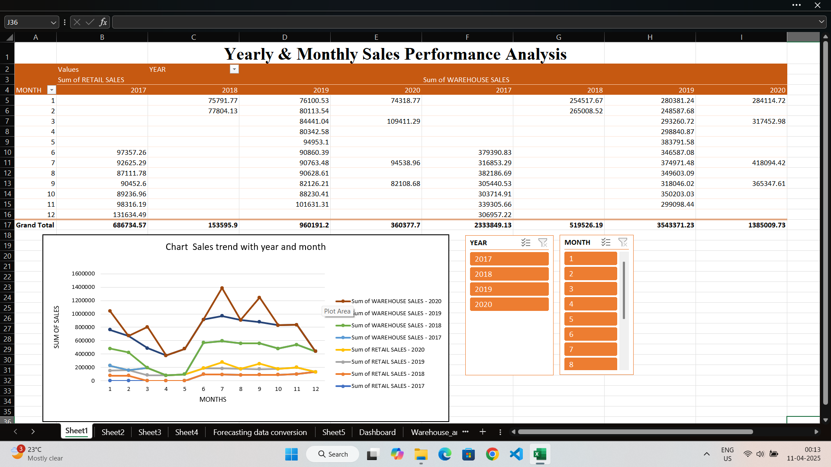

B. Supplier Performance & Contribution Analysis
I. General description
This analysis identifies the top-performing suppliers based on their contribution to retail and warehouse sales.

II. Specific requirements
- Sources: Sheet2
- Key fields: supplier, sum of warehouse sales, sum of retail sales, sum of total sales
- Method: Ranking suppliers according to the total sales result.

III. The results of the analysis
Among the main suppliers CROWN IMPORTS and MILLER BREWING COMPANY, which show dominance in both the warehouse and retail sales.

The TOP 5 suppliers contribute to a significant share in total sale, which emphasizes the importance of maintaining strong relationships with them.

Suppliers are:-
- CROWN IMPORTS
- MILLER BREWING COMPANY
- ANHEUSER BUSCH INC
- HEINEKEN USA
- E & J GALLO WINERY

IV. Visualization
The stacked bar chart was used to highlight the top 5 suppliers based on the total sales contributions.
- Each bar is segmented into retail and stock components and emphasizes supplier distribution channels.
- Placing the description provides accurate sales values ​​and supplier filters allow users to focus on individual or grouped performance.
- Monthly and Yearly slicers used are also placed.

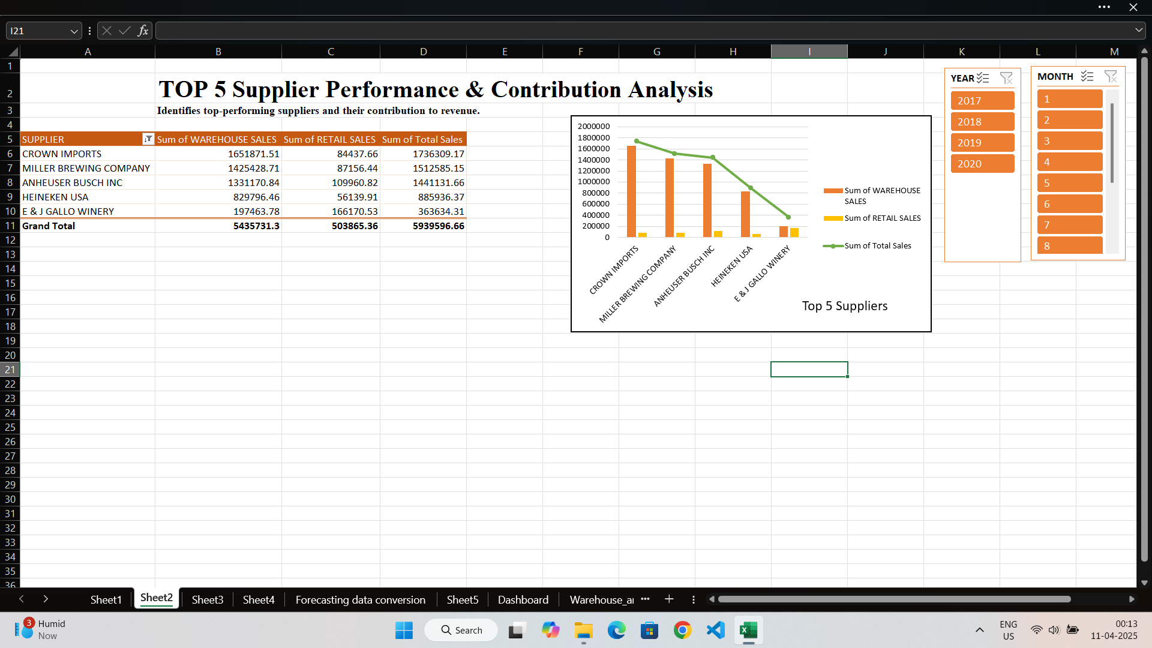
C. Product Sales Performance & Profitability
I. General description
Analyzes which product types (e.g., Beer, Wine, Liquor) works best in terms of sales and profit contribution.

II. Specific requirements
- Sources: Sheet3
- Key columns: item type, sum of retail sales, sum of warehouse sales
- Method: Aggregation of sales by product category.

III. The results of the analysis
- Liquor leads in retail sales, followed by wine and beer whereas Beer contributes most in warehouse sales followed by wine and liquor.
- The margin of profitability is the highest for the liquor for retail sales and Beer for warehouse sales, which suggests as the most valuable category of products.

IV. Visualization
A clustered column chart was created to visualize sales performance across item types (Beer, Wine, Liquor).
- Bars for warehouse sales and line chart for retail sales are placed side by side for each product category to compare their profitability.
- A profit margin indicator overlay helps users quickly identify the most profitable categories visually.

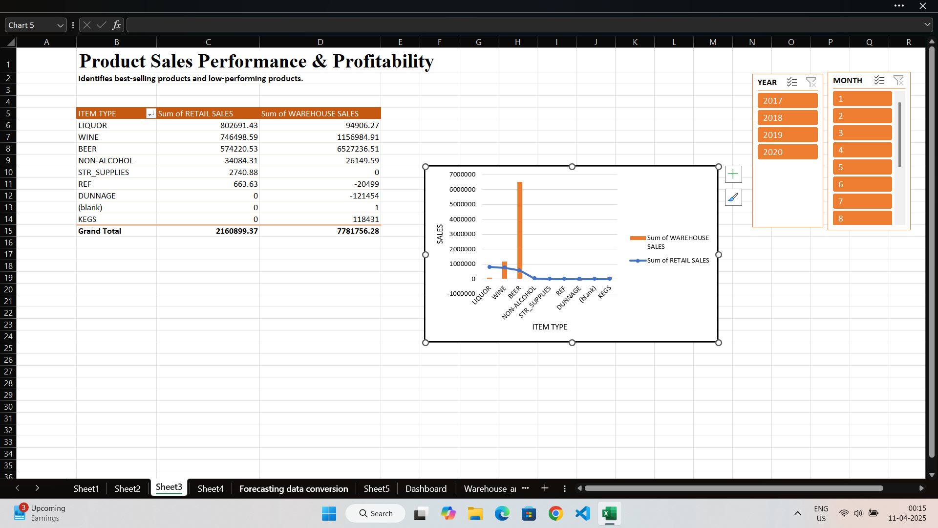
D. Sales Forecasting & Trend Projection
I. General description
Forecasts future sales based on historic trends that will help with stocks and financial planning.

II. Specific requirements
- Sources: Sheet4 and Data Conversion Prognosis
- column used : Year, Month and Total Sales
- Key columns: Timeline, values, Forecast, lower & upper confidence bound
- Method: Forecasting of time series with trend lines and confidence intervals.

III. The results of the analysis
- The sale shows an ascending trend with the expected increase to next year.
- The forecasting model includes trust boundaries and provides the expected scope for future sales values.
- The highest growth is projected in the 4th quarter of the year, probably due to seasonal effects.

IV. Visualization
Forecast line graph was used to display historical sales trends together with projected values.
- The main line indicates the actual sale, while the estimated values ​​are displayed with dashed lines and confidence bounds are shaded around the forecast .

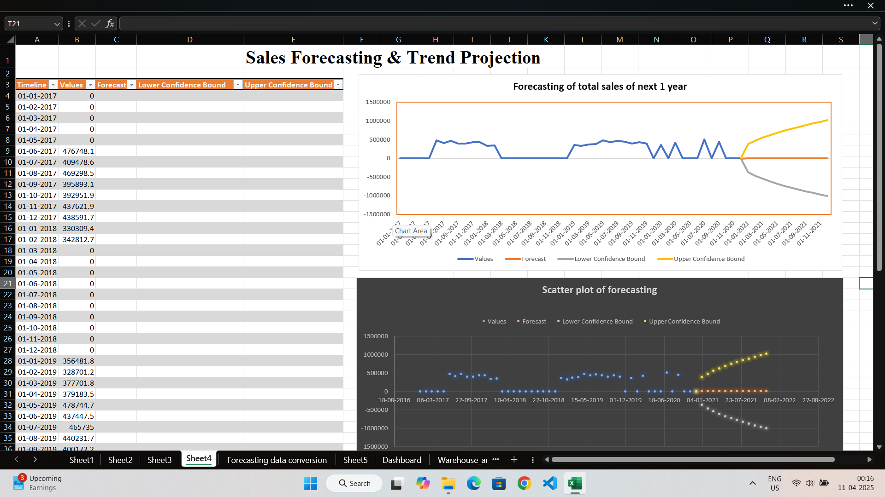
E. Customer Demand & Purchase Patterns
I. General description
Studies what customers buy and how demand changes over the years and product types.

II. Specific requirements
- Source: Sheet5
- Key columns: item type, sum of retail sales, sum of warehouse sales by year and month
- Method: annual comparison of sales of product category.

III. The results of the analysis
- The demand of beer in 2019 increased sharply, then dropped in 2020 for warehouse sales and for retail sales dropped for beer in 2018.
- The sale of wine is overall stable, while the demand for alcohol has been growing over the years.
- The trend shows changing customer preferences, possibly influenced by marketing or socio-economic factors.

IV. Visualization
The clustered area chart has been implemented to illustrate demand for shifting across products over the years.
- Each layer represents the type of item and the total area shows overall customer purchase volume.
- Filters of the year and months allow dynamic segmentation, allowing you to examine how customers preferences develop over time.
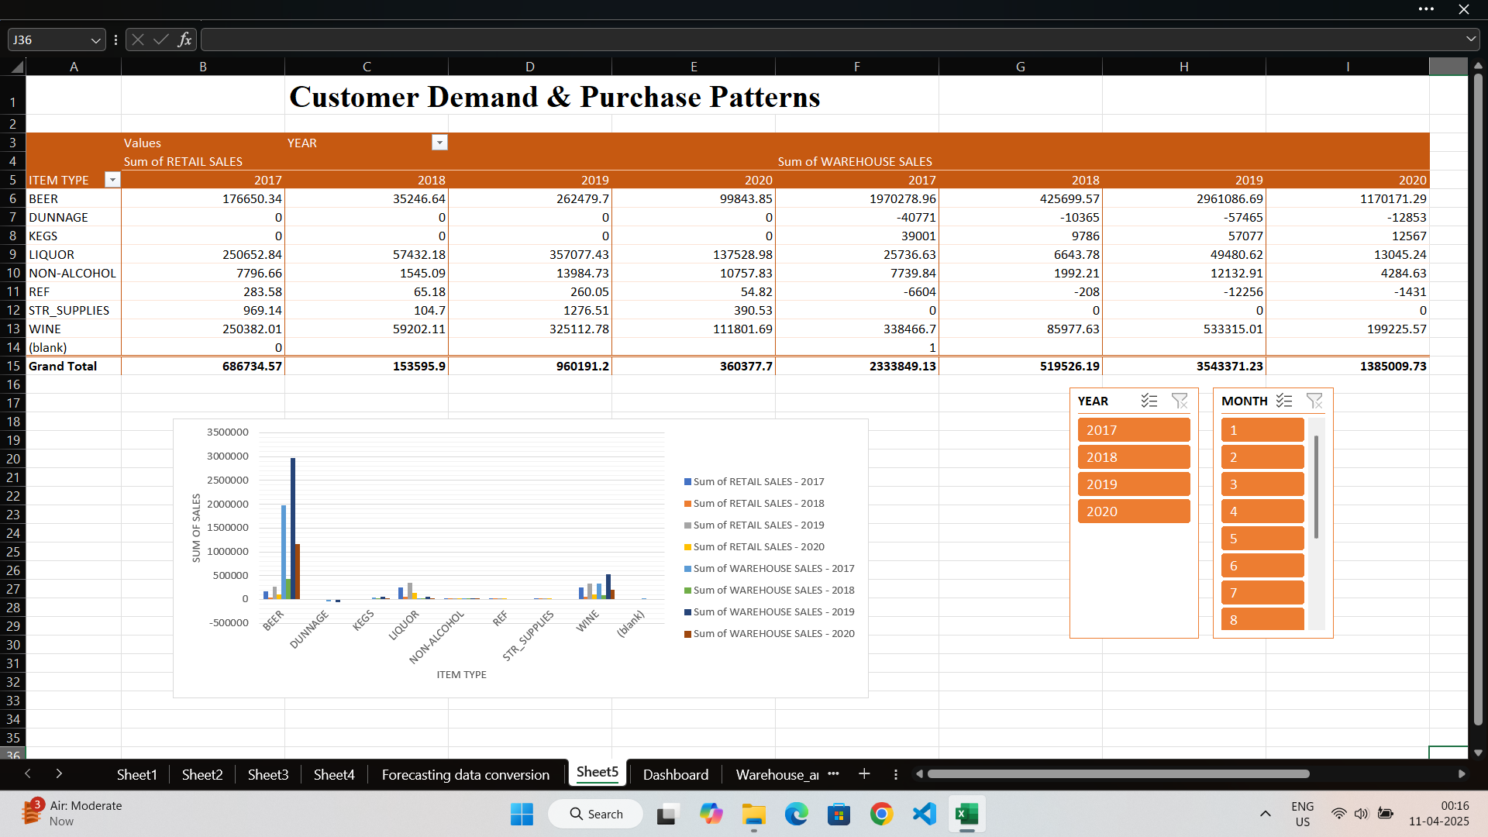

5. Conclusion

This analysis reveals a beverage distribution model heavily skewed toward warehouse sales (78.6% of total), with BEER as the primary revenue driver (70.5%). Top suppliers like CROWN IMPORTS and MILLER BREWING COMPANY dominate, contributing nearly 60% of sales, while seasonal peaks in July and September offer opportunities for targeted strategies. The retail channel, though smaller, shows efficiency in liquor sales, suggesting a balanced approach could optimize overall performance. Average transaction values highlight premium retail opportunities (e.g., FIFTH GENERATION INC) and bulk warehouse efficiency (e.g., CROWN IMPORTS).

6. Future Scope

The insights derived from this project lay a foundation for several future enhancements and practical applications:
- Expanded Data Integration: Incorporating cost data to assess profitability by channel and supplier, using formulas like Profit = Total Sales - Cost to calculate margins. Extending the dataset beyond 2025 would enable long-term trend analysis.
- Predictive Analytics: Applying more suitable time-series forecasting models (e.g., ARIMA) to predict seasonal sales peaks, enhancing inventory planning and marketing efforts.
- Consumer Insights: Integrating consumer demographics or purchase behavior data to understand demand drivers, potentially using clustering techniques (e.g., K-means) to segment customers.
- Uses and Benefits:
  - Inventory Optimization: Seasonal insights (e.g., July peaks) can guide stock replenishment, reducing overstocking or shortages and improving cash flow.
  - Supplier Negotiations: Identifying top performers like CROWN IMPORTS empowers businesses to negotiate better terms or expand partnerships, boosting profitability.
  - Marketing Strategies: Targeting high-transaction-value suppliers (e.g., FIFTH GENERATION INC) for retail promotions can increase per-customer revenue, while warehouse trends inform bulk sales campaigns.
  - Operational Efficiency: Understanding retail vs. warehouse dynamics aids in resource allocation, such as staffing retail outlets for liquor sales or scaling warehouse capacity for beer distribution.
  - Industry Benchmarking: This analysis can serve as a benchmark for competitors or regulators, offering a standardized view of sales performance in the beverage sector.
- Broader Impact: The project’s methodology and findings could be adapted to other industries (e.g., food, retail goods), providing a scalable framework for sales analysis and strategic planning.
These advancements would transform this project into a robust tool for decision-making, benefiting distributors, suppliers, and retailers by enhancing efficiency, profitability, and market responsiveness.

7. References

- U.S. Government Website for Dataset
- W3Schools
- TutorialsPoint

8. Links

- LinkedIn: https://www.linkedin.com/posts/abhishekkashyap14_exceldashboard-salesdata-trendanalysis-activity-7316178346785021953-wZ5J?utm_source=share&utm_medium=member_desktop&rcm=ACoAAEfp3S0Ba3IvL0fleFhRRq8j_I2LqrBbOCI
- Github:https://github.com/inabhishek/Warehouse-Retail-Sales-analysis

9. Dashboard
